 |  | Car #
 | 2019 International  Rally of Whangarei  INDIVIDUAL ENTRY FORM |  |  |  |  |  |  | 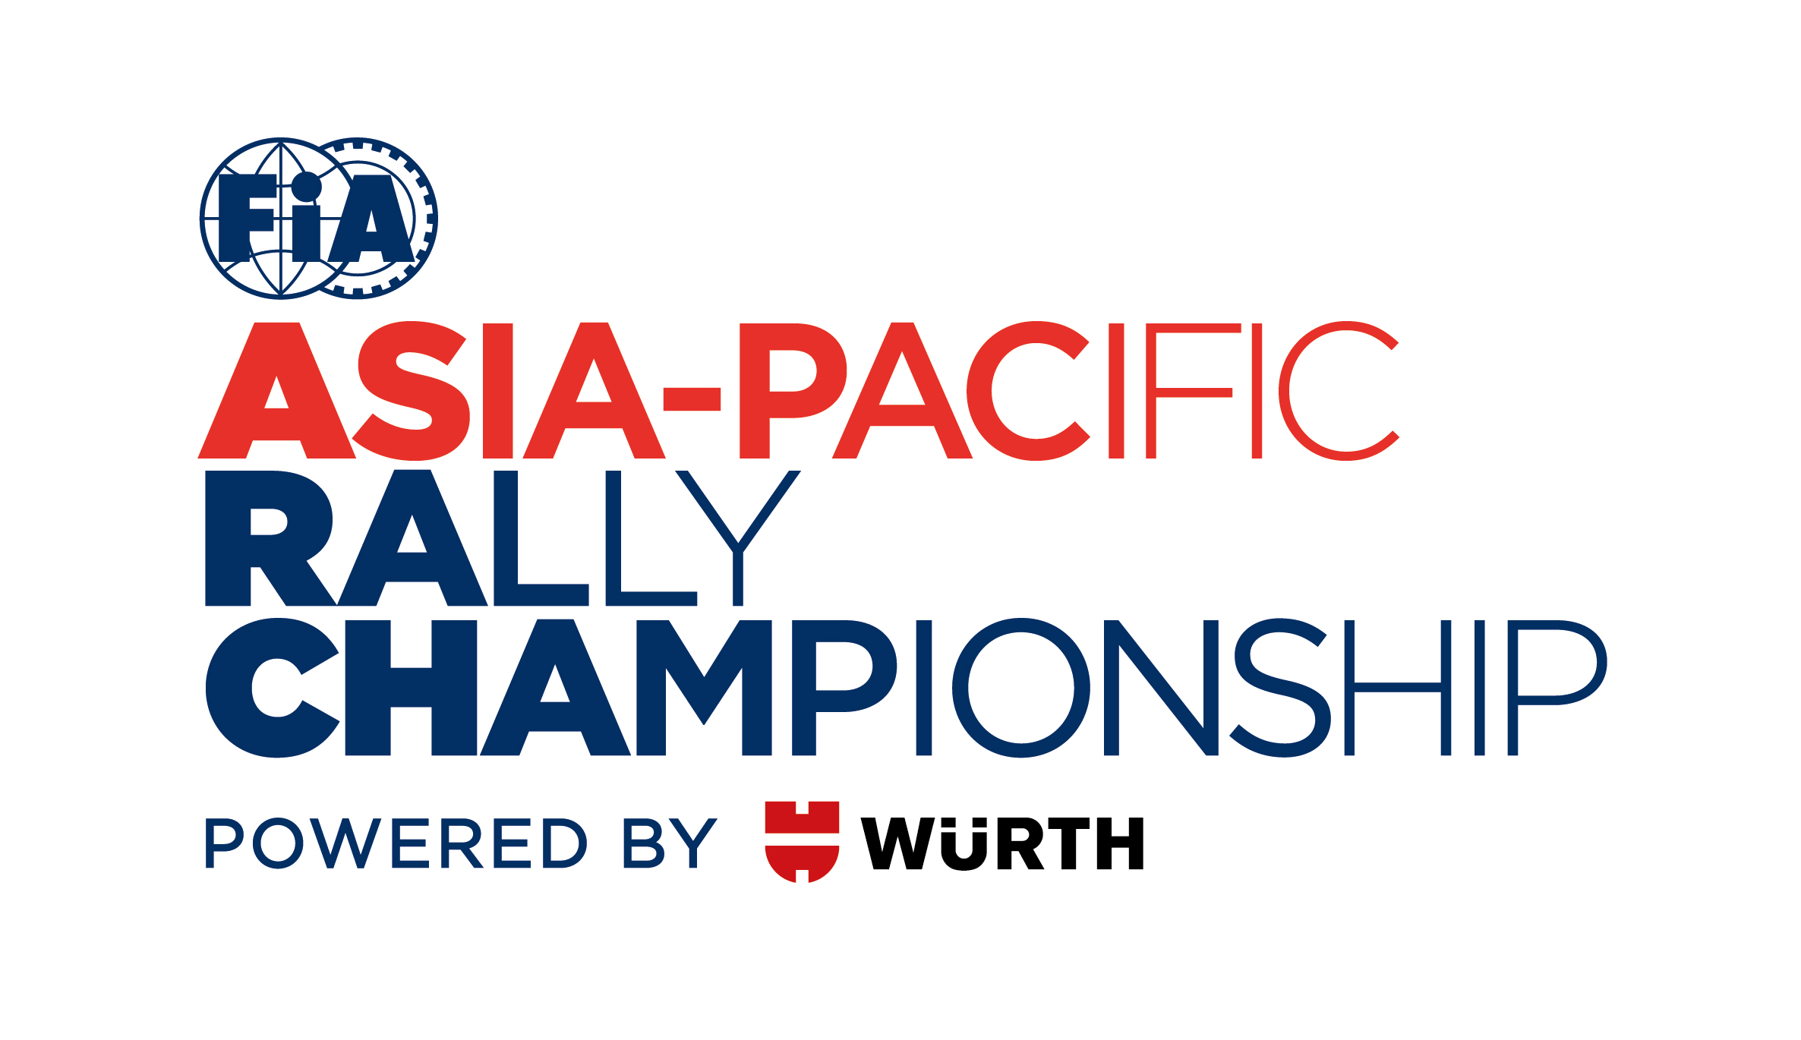
 | COMPETITOR |  |  |  | FIRST DRIVER |  |  | CO-DRIVER
Competitor Name
Surname
First (given) Name
Date of Birth
Place of Birth
Nationality (as licence)
Postal Address
Postal Address | Postcode |  |  |  | Postcode |  |  | Postcode
Passport Number
Address for correspondence (1,2 or 3) | 1. |  |  |  | 2. |  |  | 3.
Telephone Nº (business)
Telephone Nº (private)
Mobile Tel Nº
Fax Nº
Email Address

Competition Licence Nº
Issuing ASN
Driving Licence Nº
Country of Issue

NZ COMPETITORS ONLY
Expiry date of Comp. License
License Grade
Foreign Participant on Non-MSNZ Licence |  |  | Yes / No |  | Yes / No
Financial Member Of
(Name Of Car Club)
Currently is your NZ civil drivers licence disqualified? (NZ only) |  |  | Yes / No |  | Yes / No
If YES, then you must sign a declaration at Documentation as per NSC 43(2)(b)
Age Group (Please Circle Applicable Group) |  |  |  | Under 19 19-25 26-35 36-60 61 Plus | Under 19 19-25 26-35 36-60 61 Plus
Emergency Contact Name
Emergency Contact Phone
New Competitor Briefing:  If contested less than three rallies attendance is compulsory |  |  |  | Please tick here if you are required to attend the briefing: | Please tick here if you are required to attend the briefing:

DETAILS OF THE CAR
Make |  | Registration Nº
Model |  | C.C.
Year of Manufacture |  | Chassis Nº
Group / Class |  | Homologation N^{o (if applicable)}
Country of Registration |  | Technical Passport Nº (if applicable)  NZ Cars = Log Book No
License Plate Nº |  | Turbo (circle) | Yes / No
Restrictor (circle) | Yes / No | Restrictor size
Safety compliance (circle) | FIA or National regulations

TYPE OF ENTRY
Trade/Legal, etc.
Private /Amateur
Organisers’ proposed advertising accepted | Yes / No (If No, please add NZ$1,000 to entry type)

STAGE NOTES
Stage notes are available at a cost of NZ$250 per set. For those competitors wishing to purchase Stage Notes you must order direct through Neil Allport Motorsport website www.allports.nz  For administration purposes, please indicate if you will be ordering Stage Notes. | (Circle)  YES | (Circle)  NO

ENTRY FEES
For this Entry Form to be valid it must be accompanied by the appropriate entry fees, a receipt for the full amount paid to the competitor’s ASN, a banker’s draft or details of a bank transfer, etc.
ENTRY TYPE | AMOUNT | CLOSING DATE | TICK

New Zealand Rally Championship Competitors
NZRC Cat 1-4 With optional advertising proposed by Organisers | NZ$2,550 | 5pm Monday 15 April
NZRC Cat 5 With Optional advertising proposed by Organisers | NZ$1,167 | 5pm Monday 15 April

Others
With optional advertising proposed by Organisers | NZ$2,316 | 5pm Monday 15 April

Additional fees:
International Competitor fee | NZ$500
Without optional advertising proposed by the Organisers please add NZL$1,000 | NZ$1,000 | 5pm Monday 15 April
Coverage of the MSNZ Insurance excess of $3,500 (NZRC Cat 5 and day one competitors Only) | NZ$50 | 5pm Monday 15 April

SEEDING INFORMATION
(to be completed by competitor)
Driver Name |  |  |  |  | Car |  |  |  |  | Class
Current FIA Priority |  |  |  | Yes / No | Previous FIA Priority |  |  |  |  | Year:
Current National Seeded |  |  |  | Yes / No | Previous National Seeded |  |  |  |  | Year:
Title of any Championship won |  |  |  |  |  |  |  |  |  | Year:

PREVIOUS RESULTS
 | Year | Event |  | Car |  |  | Group | O/A  Position | Class  Position |  |  | No of  Finishers
International
National

Other

DECLARATION OF INDEMNITY
1. In consideration of the acceptance of this entry and of my being permitted to take part in the Meeting or Events detailed,
I agree not to pursue claims against and (severally) to hold harmless, indemnify and keep indemnified MotorSport New Zealand Inc, its members, associated or affiliated clubs and entities, rally and/or event organisers and promoters, the inviting club and entity (or entities), race circuit owners, providers and operators, owners and tenants of private property (including land, buildings and/or fixtures, fittings and chattels) traversed, or proximate to events, officials, fellow competitors, and the directors, officers, servants, representatives and agents of those entities (all together “the Indemnified Parties”) in relation to all losses, actions, expenses, costs, liabilities, claims and demands in respect of death, injury, loss or damage to persons or property of myself, and/or my team (including drivers, co-drivers, passengers, management and/or mechanics) whatsoever, caused or arising out of or in connection with this entry or taking part in the events to which this entry relates, notwithstanding that such death, injury, loss or damage may have been contributed to or caused by the negligence of any of the Indemnified Parties and/or by any other person. This provision confers a benefit on, and is intended to be enforceable by, each of the Indemnified Parties (in accordance with the Contracts (Privity) Act 1982).
2. Ability to Control a Vehicle Declaration by Driver:
I declare that should I at the time of any event this entry form relates to be suffering from any disability of any kind whether permanent or temporary which is likely to detrimentally affect my control of my automobile or my fitness to drive, I will not participate.
3. Consent:
I consent to the details contained on this form being held by MotorSport New Zealand Inc. and Rally of New Zealand Ltd for the purpose of the promotion and benefit of the Rally Event(s) concerned, and Motorsport in general. I acknowledge my right to access and correction of this information. This consent is given in accordance with the Privacy Act 1993.
I also authorise the medical providers of the event to disclose medical information relevant to injury or illness sustained during the above mentioned event to the FIA, MotorSport New Zealand Inc, Rally of New Zealand Ltd and its officials.
ACKNOWLEDGEMENT AND AGREEMENT
By my signature, I declare that all the information contained on the Entry Form is correct and that I acknowledge and agree in full to the terms and conditions of the above indemnity and that I accept all the terms and conditions relating to my participation in this event.
ASN Stamp* | Signature of Competitor | Signature of Driver | Signature of Co-Driver
* Or letter from the competitor’s ASN authorising and approving the entry Date _____ / ______ / ______

